Program Viability Report: Marketing Management

Topline:

Training in marketing provides opportunities in a variety of careers ranging from creative jobs in advertising or promotions to more analytical positons in marketing research. This report provides labor market trends and median wages for some marketing related careers. Over the next five years (2015 to 2020), growth is projected for most marketing related careers. Moreover, median hourly earnings in the Los Angeles MSA outpace the nation’s median hourly wage. Among the marketing related careers featured in this summary, Marketing Research Analysts and Marketing Specialists will encounter the most growth as jobs in this field are projected to increase by double-digits in the Los Angeles MSA, LA County, California, United States and PCC service area. Moreover, job posting in the Los Angeles MSA are above the national average.

The majority of marketing jobs require a bachelor’s degree or higher.

Below are bullets for the Los Angeles MSA from 2015 to 2020 for each occupation featured in the report:

- Market Research Analysts and Marketing Specialists are projected to grow by 10.3%; current median hourly earning equal $30.86.

- Marketing Managers are projected to grow by 4.6%; median hourly wages equal $61.57.

- Advertising and Promotions Manager is projected to increase by 5.0%; median hourly wages equal $54.20.

- Public Relations Specialist are projected to increase by 8.4%; median hourly wages equal $31.01.

- Public Relations and Fundraising Manager are projected to grow by 8.8%; median hourly wages equal $49.15.

- Sales Representatives are projected to increase by 2.5%; median hourly wages equal $24.69.

Market Research Analysts and Marketing Specialists
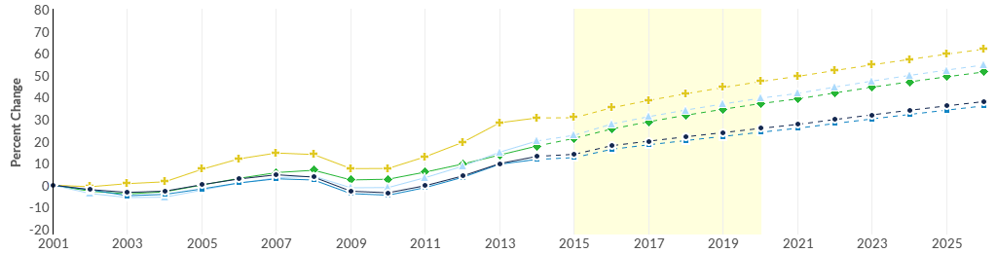
 | Region | 2015 Jobs | 2020 Jobs | Change | % Change
● | LA MSA | 29,799 | 32,874 | 3,075 | 10.3%
● | LA County | 20,924 | 23,068 | 2,144 | 10.2%
● | California | 81,810 | 93,038 | 11,228 | 13.7%
● | United States | 514,396 | 581,351 | 66,955 | 13.0%
● | PCC Service Area | 1,026 | 1,155 | 129 | 12.6%

Occupation Summary for Market Research Analysts and Marketing Specialists
30,818 | 10.3% | $30.86/hr
Jobs (2016) | % Change (2015-2020) | Median Hourly Earnings
37% above National average | Nation: 13.0% | Nation: $29.92/hr

Marketing Managers
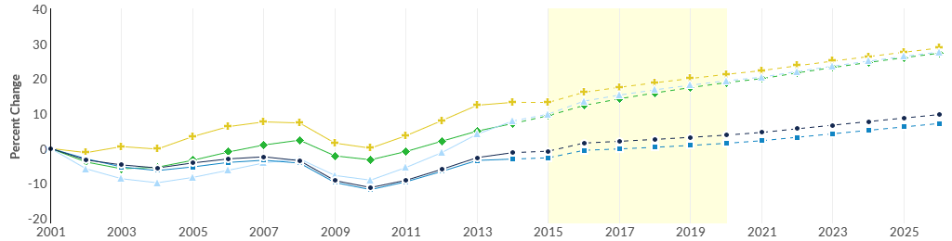
 |  | Region |  | 2015 Jobs | 2020 Jobs |  | Change | % Change
 | ● | LA MSA |  | 11,145 | 11,662 |  | 517 | 4.6%
 | ● | LA County |  | 7,436 | 7,754 |  | 318 | 4.3%
 | ● | California |  | 35,256 | 38,317 |  | 3,061 | 8.7%
 | ● | United States |  | 203,165 | 220,756 |  | 17,591 | 8.7%
 | ● | PCC Service Area |  | 378 | 404 |  | 26 | 6.9%
Occupation Summary for Marketing Managers
11,406 |  |  | 4.6% |  |  | $61.57/hr
Jobs (2016) |  |  | % Change (2015-2020) |  |  | Median Hourly Earnings
29% above National average |  |  | Nation: 8.7% |  |  | Nation: $59.46/hr

Advertising and Promotions Manager
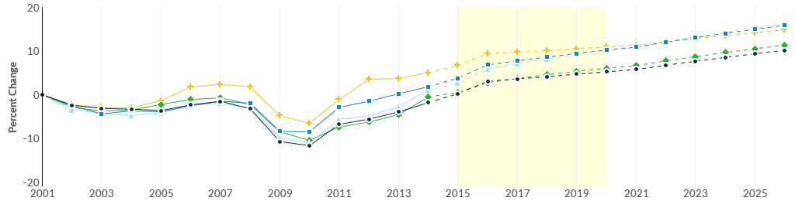
 |  | Region |  | 2015 Jobs | 2020 Jobs |  | Change | % Change
 | ● | LA MSA |  | 2,274 | 2,388 |  | 114 | 5.0%
 | ● | LA County |  | 1,837 | 1,951 |  | 114 | 6.2%
 | ● | California |  | 4,820 | 5,167 |  | 347 | 7.2%
 | ● | United States |  | 32,555 | 34,351 |  | 1,796 | 5.5%
 | ● | PCC Service Area |  | 67 | 70 |  | 3 | 4.5%
Occupation Summary for Advertising and Promotions Managers
2,339 |  |  | 5.0% |  |  | $54.20/hr
Jobs (2016) |  |  | % Change (2015-2020) |  |  | Median Hourly Earnings
66% above National average |  |  | Nation: 5.5% |  |  | Nation: $48.40/hr

Public Relation Specialist
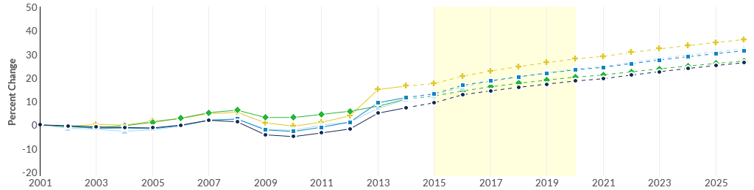
 | Region |  | 2015 Jobs | 2020 Jobs |  | Change | % Change
● | LA MSA |  | 9,176 | 9,949 |  | 773 | 8.4%
● | LA County |  | 7,488 | 8,159 |  | 671 | 9.0%
● | California |  | 25,525 | 28,027 |  | 2,502 | 9.8%
● | United States |  | 232,165 | 248,689 |  | 16,524 | 7.1%
● | PCC Service Area |  | 355 | 387 |  | 32 | 9.0%
Occupation Summary for Public Relations Specialists
9,460 |  | 8.4% |  |  | $31.01/hr
Jobs (2016) |  | % Change (2015-2020) |  |  | Median Hourly Earnings
5% below National average |  | Nation: 7.1% |  |  | Nation: $27.53/hr

Public Relations and Fundraising Managers
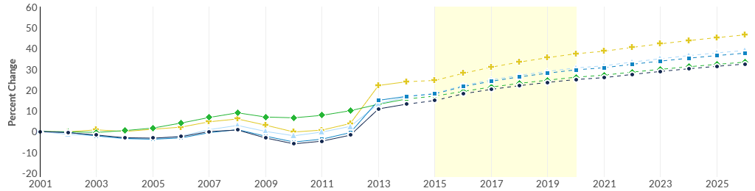
 |  | Region |  | 2015 Jobs | 2020 Jobs |  | Change | % Change
 | ● | LA MSA |  | 2,558 | 2,784 |  | 226 | 8.8%
 | ● | LA County |  | 1,973 | 2,166 |  | 193 | 9.8%
 | ● | California |  | 7,253 | 8,004 |  | 751 | 10.4%
 | ● | United States |  | 62,123 | 66,945 |  | 4,822 | 7.8%
 | ● | PCC Service Area |  | 111 | 122 |  | 11 | 9.9%
Occupation Summary for Public Relations and Fundraising Managers
2,631 |  |  | 8.8% |  |  | $49.15/hr
Jobs (2016) |  |  | % Change (2015-2020) |  |  | Median Hourly Earnings
2% below National average |  |  | Nation: 7.8% |  |  | Nation: $50.59/hr

Occupation Summary for Sales Representatives, Wholesale and Manufacturing, Except Technical and Scientific Products
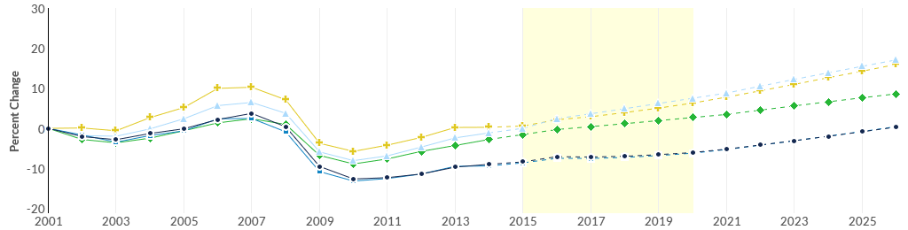
 |  | Region |  | 2015 Jobs | 2020 Jobs |  | Change | % Change
 | ● | LA MSA |  | 66,819 | 68,519 |  | 1,700 | 2.5%
 | ● | LA County |  | 48,853 | 50,142 |  | 1,289 | 2.6%
 | ● | California |  | 160,065 | 172,087 |  | 12,022 | 7.5%
 | ● | United States |  | 1,488,109 | 1,552,203 |  | 64,094 | 4.3%
 | ● | PCC Service Area |  | 970 | 1,025 |  | 55 | 5.7%
Occupation Summary for Sales Representatives, Wholesale and Manufacturing, Except Technical and Scientific Products
67,771 |  |  | 2.5% |  |  | $24.69/hr
Jobs (2016) |  |  | % Change (2015-2020) |  |  | Median Hourly Earnings
6% above National average |  |  | Nation: 4.3% |  |  | Nation: $26.25/hr

